POPOVA, LIUBOV SERGEEVNA [VON EDING]
24 April 1889, Ivanovskoe, near Moscow, Imperial Russia
25 May 1924, Moscow, RSFSR

Liubov Popova had a rich artistic training – being taught colour theory by Russian Impressionist painters and travelling in Renaissance Italy (1907-1911). Having seen the Cubism of Georges Braque and Pablo Picasso in the Moscow collection of Sergei Shchukin, Popova went to Paris in November 1912, entering the teaching studio of the Paris Cubists, Henri Le Fauconnier, Jean Metzinger and André Dunoyer de Segonzac, l’Académie de la Palette, in December. Staying until May 1913, Popova learned the basic principles of Cubist structure around multiple viewpoints. Then, as Popova later noted, “My Cubist period (the problem of form) was followed by my Futurist period (the problem of movement and colour)”. With the late 1915 exhibition of the Suprematism of Kazimir Malevich, Popova began her non-objective paintings created with raying beams of colour and light from a projector which she titled, Painterly Architectonics (Zhivopisnaia arkhitektonika, 1916-1918). From “interleaving” light she became interested in the mechanical forces and tensions of machines and pulleys in works based on “The City”, showing her Painterly-Force Constructions (Zhivopisno-Silovikh postroenii) in 1921 (5 x 5 = 25, Moscow). In her non-objective world of colour and forces, Popova was thoroughly a modernist.

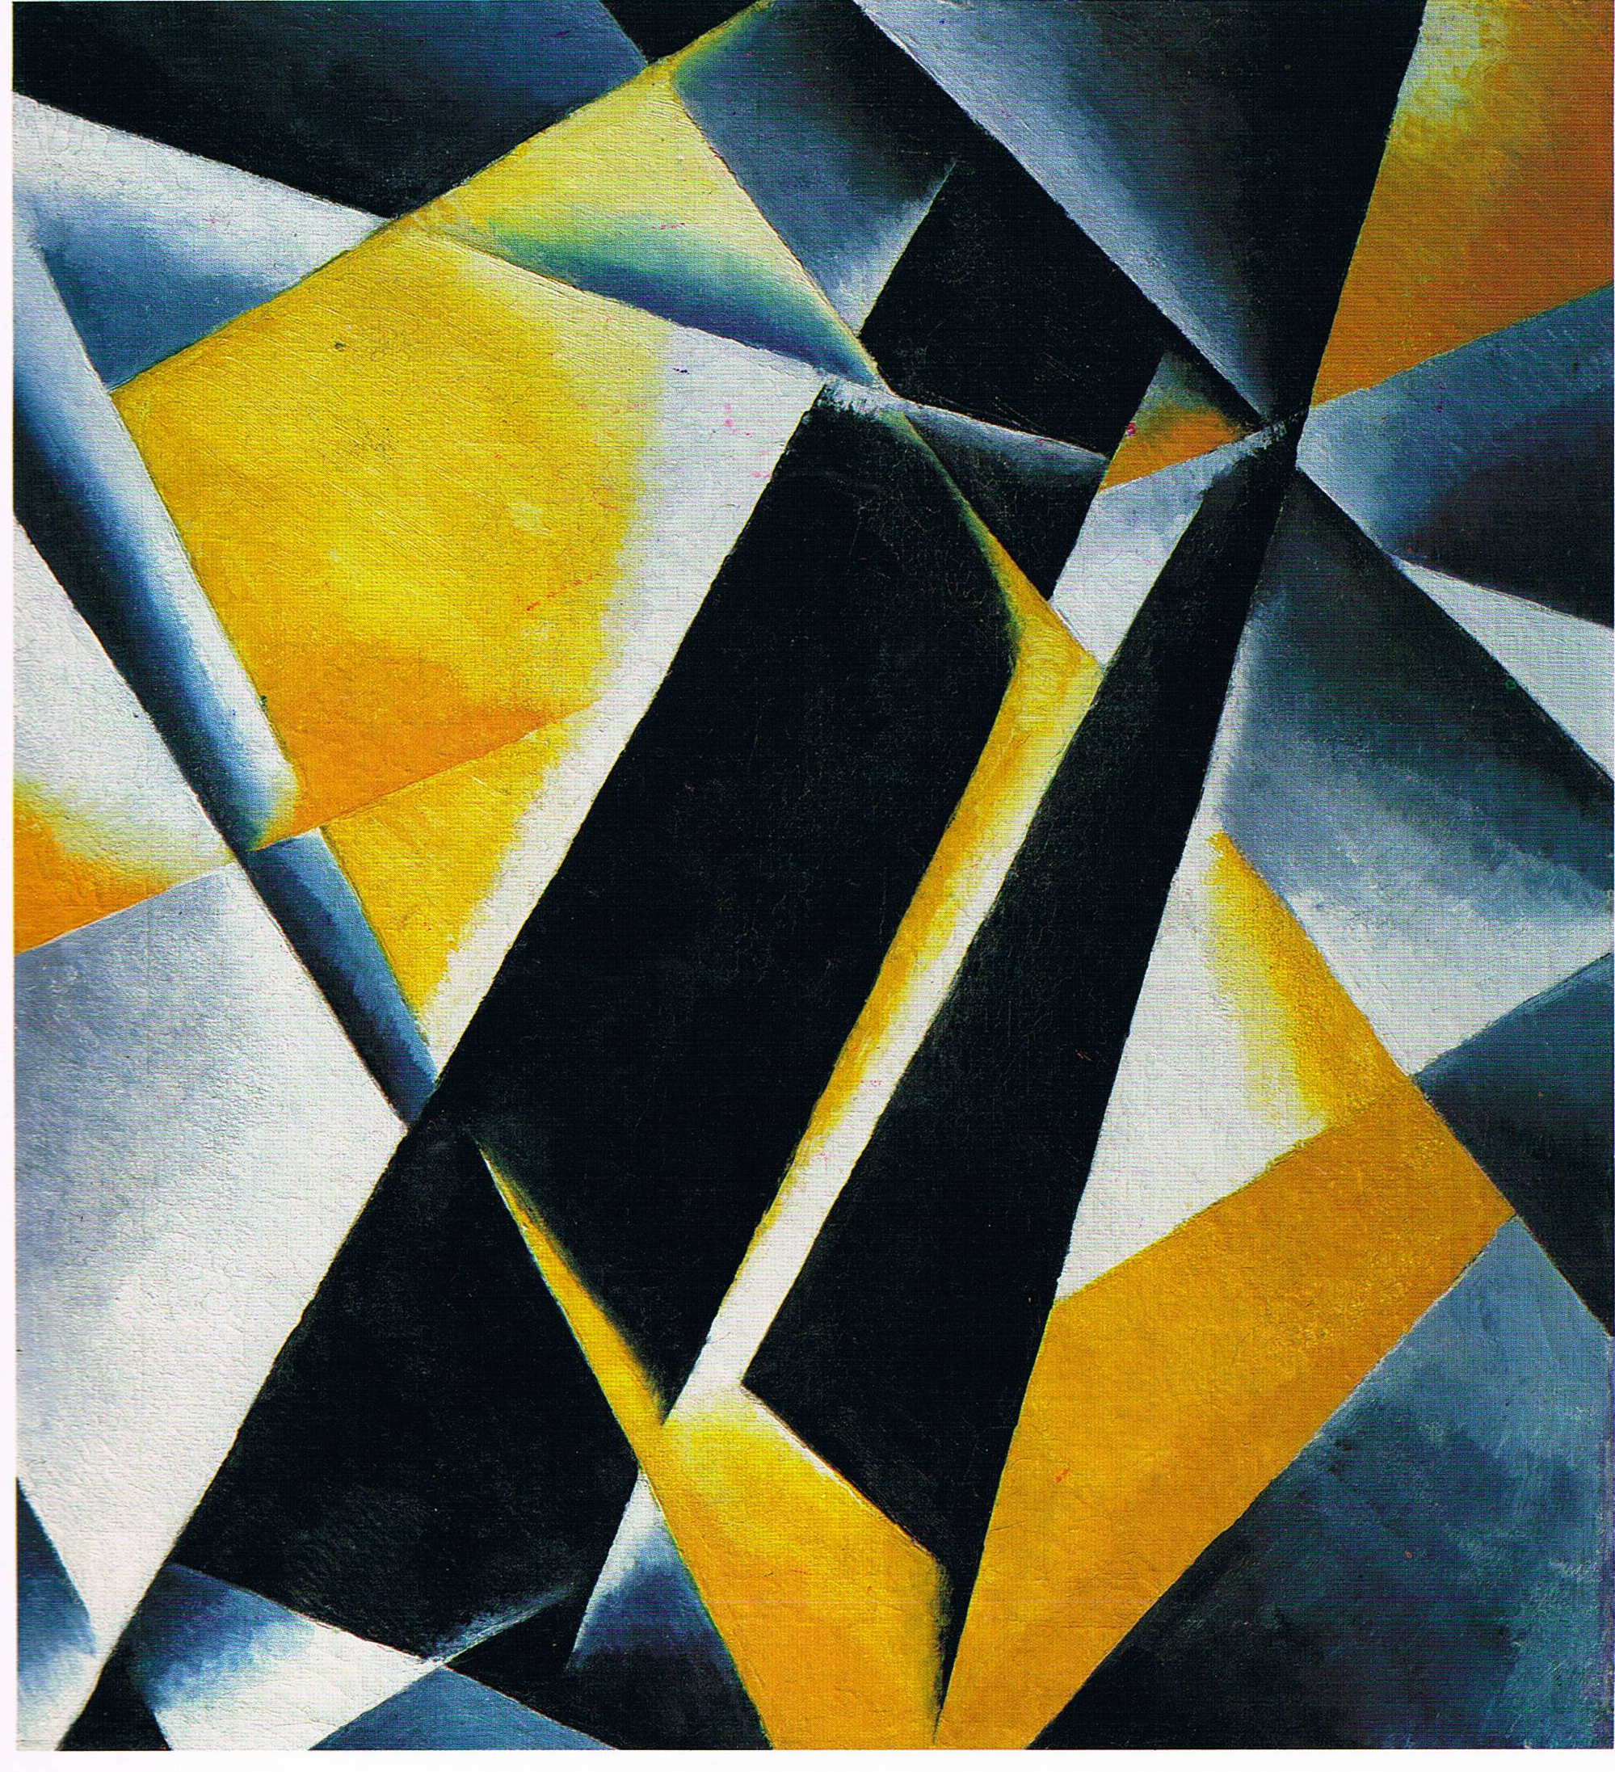
Painterly Architectonics, 1918, Oil on canvas, 58 x 53 cm.
Museum Bureau, Moscow, 1920, State Museum of Fine Arts, Gorky

A master painter of Cubist portraits and Futurist dynamism in, for example, a pianist’s movements creating the movement of sounds, or the fragments of objects and lights reflecting off windows of a speeding train, Popova’s paintings between 1913 and c. 1922 gain their power from an assured organisation and firm structure. This structure was based on a linear or curved geometricality while her colour structures were determined by the laws of spectral, prismatic light between the light-end of the spectrum – reds, oranges, yellows – and the dark-end of the spectrum – greens, blues, violets – and by the law of optical complementaries: red/green, orange/blue, yellow/violet. Popova’s paintings are characterised by contrast, by juxtapositions of opposites in straight lines and curves and between light and darkness, and it is from this law of contrast that they are able to hold the eye. It was also the law of contrast that governed Popova’s design work for the theatre, graphics and textiles. She did costumes and sets for several productions including The Magnanimous Cuckold (1922) for which she employed the cranks and wheels of modern machinery on a set that looks like scaffolding which, being three-dimensional, could be called Constructivist. Also “constructive” in the play between bold lines and contrasts was her design for books and posters (1922-1924). It was as a textile designer, however, that Popova excelled, creating hundreds of geometrical patterns for the First State Textile Print Factory (1923-1924). As she was quoted by Ivan Aksionov in 1924, “’No single artistic success gave me such profound satisfaction as the sight of peasants and workers buying pieces of my material’ and, indeed, this past spring all Moscow was wearing fabrics with designs by Popova without knowing it – vivid, strong designs full of movement, like the artist’s own nature.” Popova died of scarlet fever at the age of 35 at the height of her creative years.

References and further reading:
The George Costakis Collection – Russian Avant-Garde Art, New York: Harry N. Abrams,
Inc., 1981.
Dmitri V. Sarabianov and Natalia L. Adaskina, Popova, London: Thames and Hudson, 1990.

